**Arrow - K - Ranch**

**3801 County Road 270**

**Cameron, TX 76520**

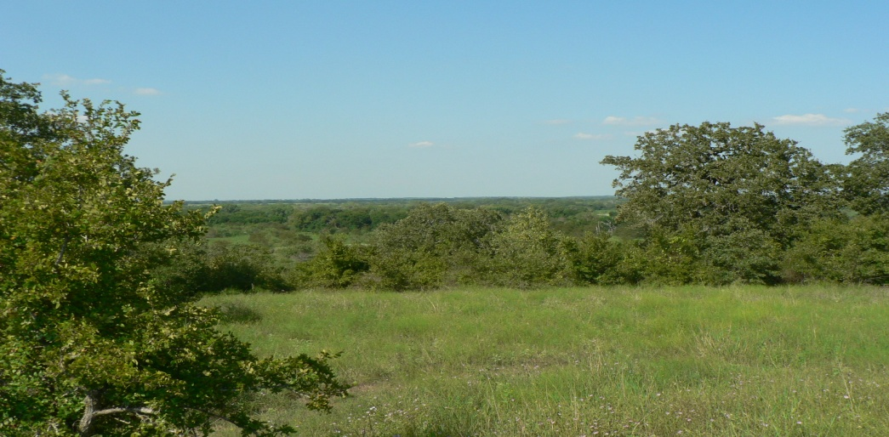

920 Acres +/-, very rolling, picturesque property with good soils and a good balance of open to wooded areas. Two water wells with more than 4 miles of water lines, spigots and shut-off valves, traverse the property. The property is native coverage with native and improved grasses.

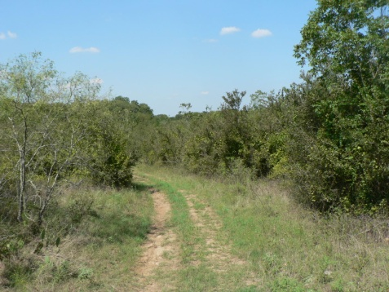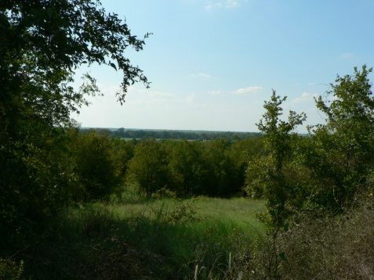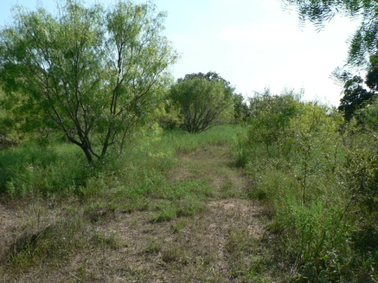

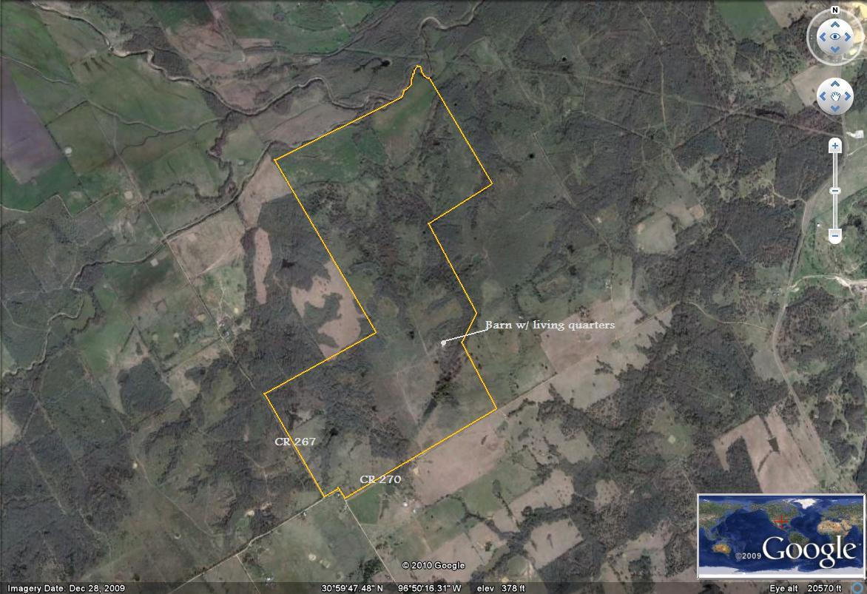

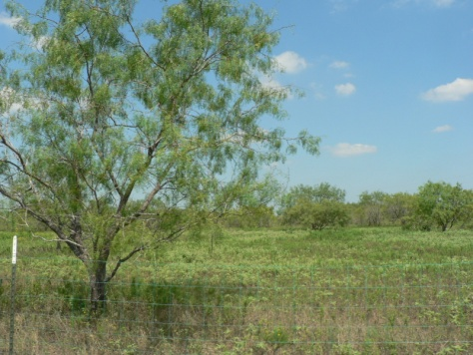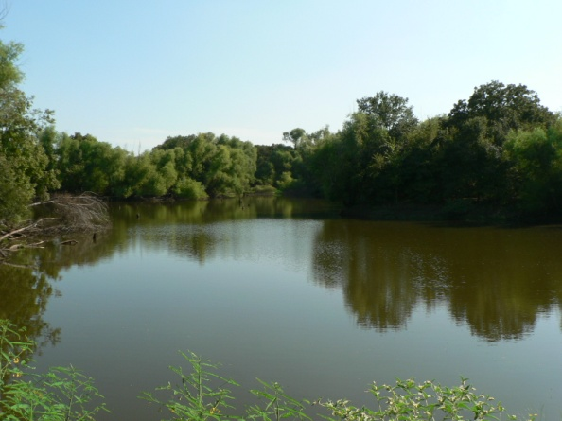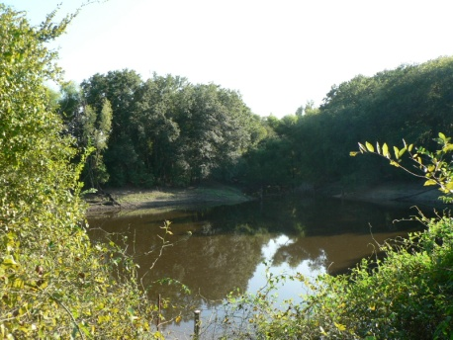

The property offers 20 ponds, miles of trails and fencing for rotational grazing.

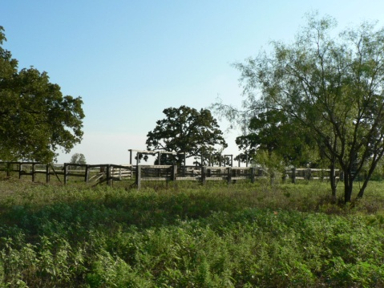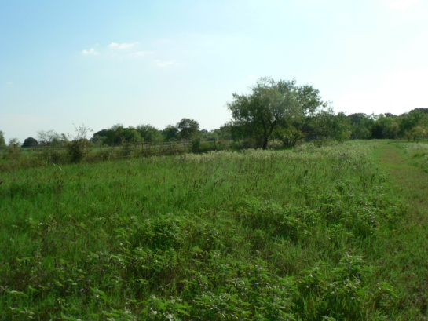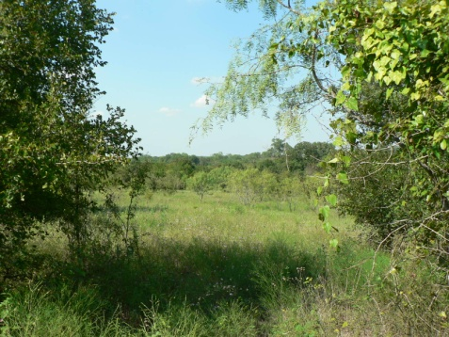

There is an extensive barn and home site area that includes a multiuse structure of more than 5,500SF of useable/livable space and storage.

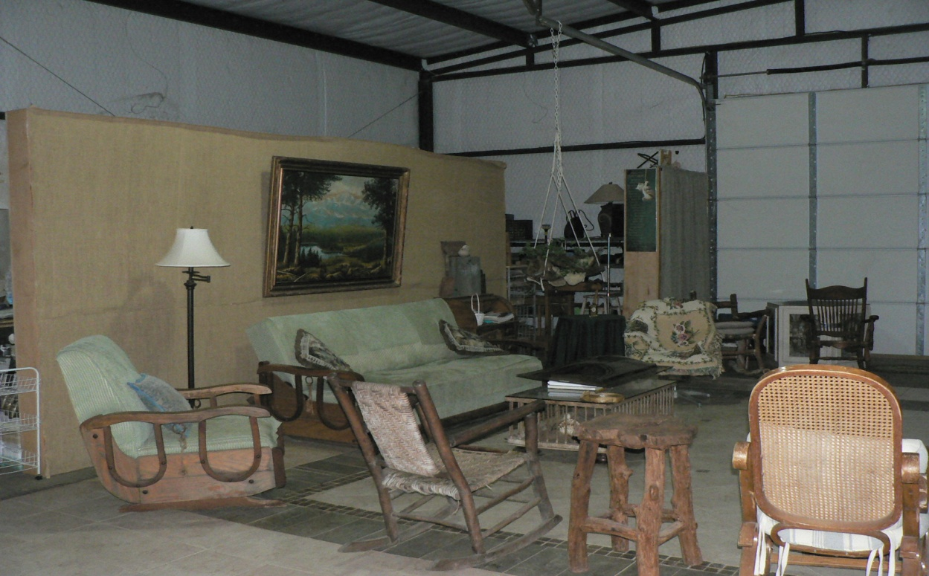

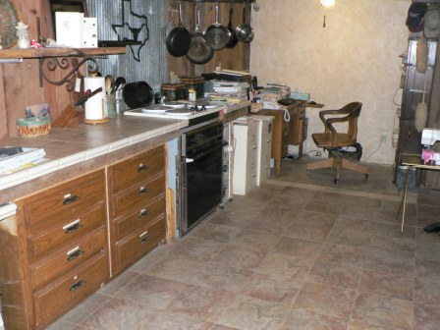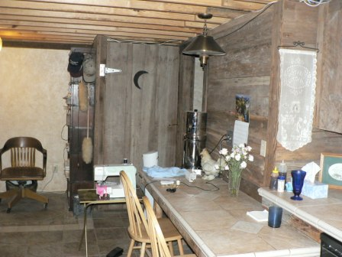

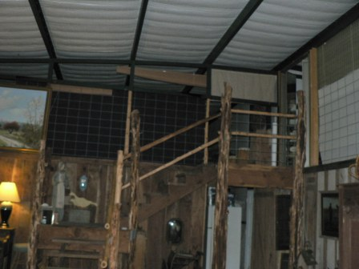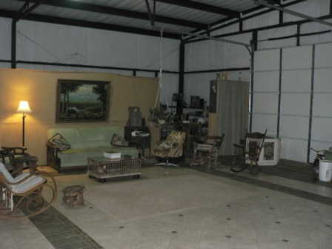

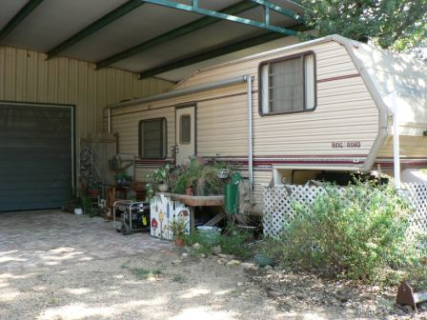

It features 4 bedroom/bunk areas with two and a half baths. There is a kitchen

area and spacious living/gathering area. This could make a great weekend retreat or hunter’s lodge. There is a fenced garden area and green house, a patio garden with elaborate brick and stone work. The floor in the entire building is hand-tiled. Additionally, there are two RV’s parked and set up for additional guest/hunter’s space.

**Offered at $ 2,144,400.00**

**($2,330/Ac)**



