**77 Acres, 1444 S FM200, Glenrose**

**$966,000**

**This 77.31 acres is a jewel of a place and a rare small acreage along the beautiful Brazos River just outside the quaint town of Glen Rose, Tx on pave FM 200. Along the river are huge Oak trees and plenty of mature Pecan trees. Bring your fishing pole-fish are jumping! There is easy access down to the river in several places while other areas have higher drops. The property has good fences with the coastal being cross fenced and along the river is fenced. Turkey hunting is very good with plenty of mature hardwoods to provide roosts. The birds are abundant especially around the river bottom. Approximately 40 acres of coastal along the south end of the property recently fertilized. Good soil for improved grasses. Thick native grass lies below the hill in the bottom land area. There is an old hay barn on the property and a non-functioning water well. The Trinity Aquifer is strong in the area with potential of new owner drilling a good producing well. County Water is available and runs along FM 200. This would make a great combination place for grazing, fishing, a little hunting or to build your new home. This is one of the**

**Cleanest places I have seen in a long time with the fence rows**

**Even being well maintained! Several gates for**

**Access along FM 200 as well as an old**

**Road on the east side that is**

**paved, ½ belongs to**

**this property**

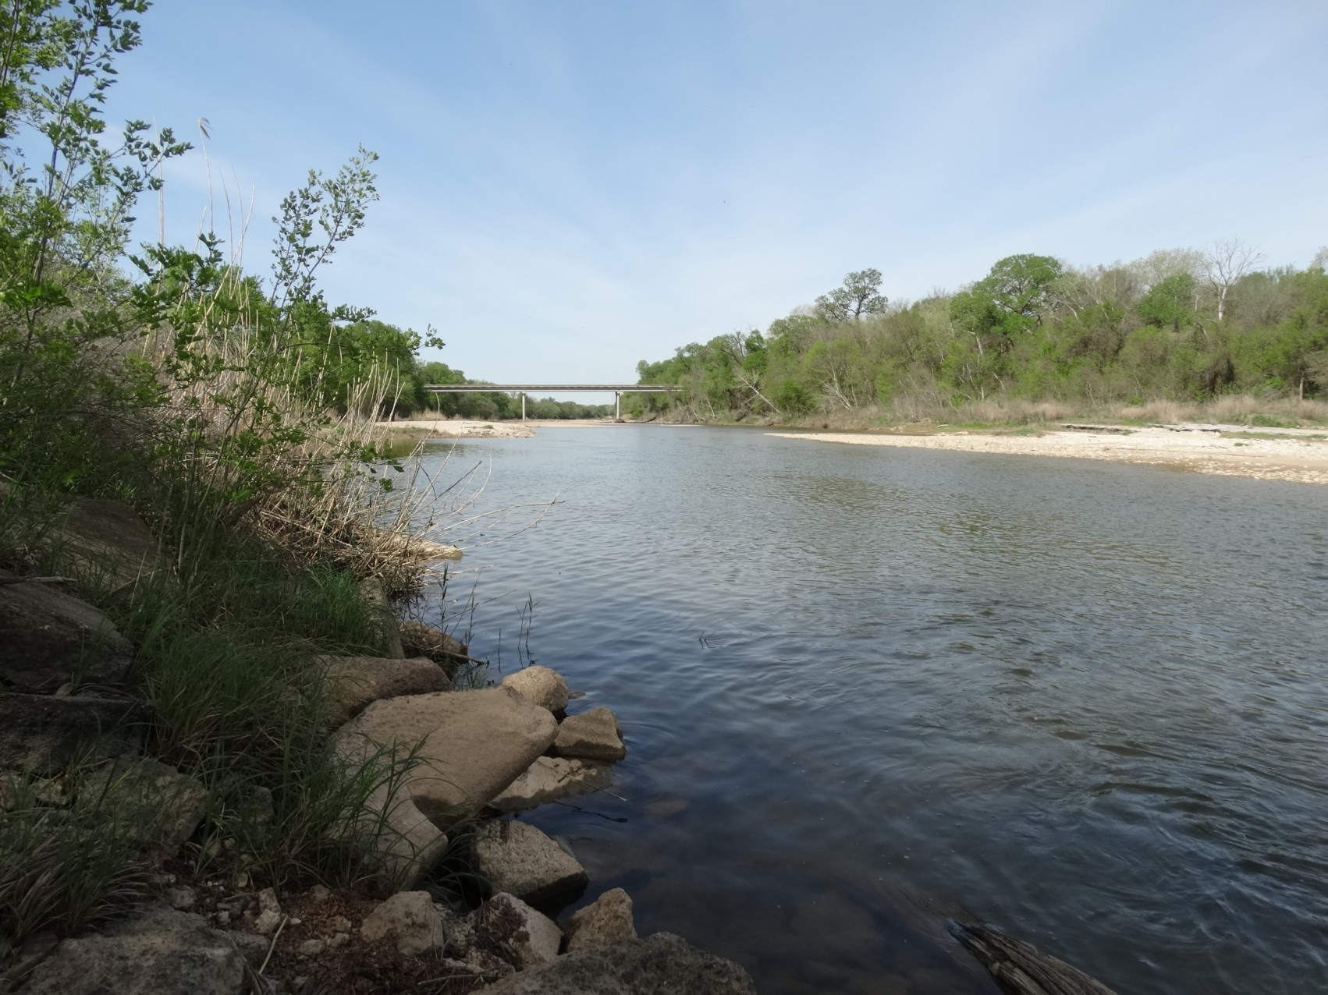

**Karen Lenz, Broker**

**325-668-3604**

**karen@trinityranchland.com**

**Mike Rogers, Agent**

**325-665-4695**

[**mikerogers775@gmail.com**](mailto:mikerogers775@gmail.com)

**www.trinityranchland.com**





**601 E I-20**

**Cisco TX 76437**

**254-442-4181**

225 SW 5th Street

Cross Plains, TX 76443

254-725-4181



All information contained herein is supplied by the seller to the best of his/her knowledge. Trinity Ranch Land Real Estate assumes no responsibility for misprints or misinformation provided to us. We will assist all buyers in verifying the information contained herein to the best of our ability.

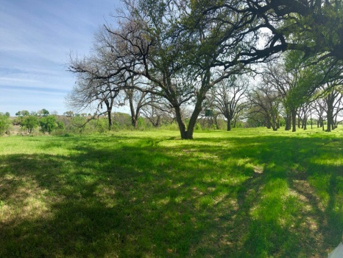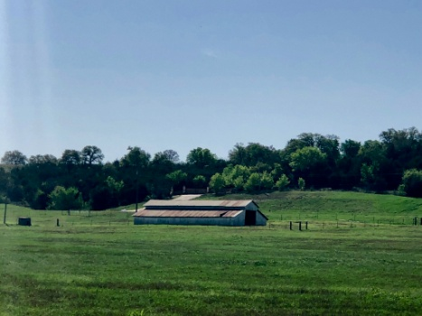­­

**FEATURES**

* County- Somervell
* Schools-Glen Rose ISD
* Pasture-
* Cultivated-40 Ac Coastal
* Water- Along FM 200
* Soil Type-Sandy Loam
* Terrain-Gently rolling

* Outbuildings-Old Hay Barn
* Minerals owned-unknown
* Minerals Convey-unknown
* Ag Exempt-Yes
* Taxes-$328 approx
* **Price Per Acre- $12,495**
* **Price-$966,000**
* **MLS-13811808**

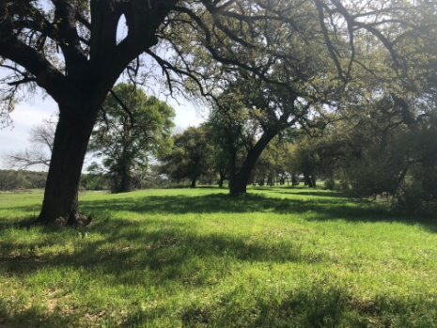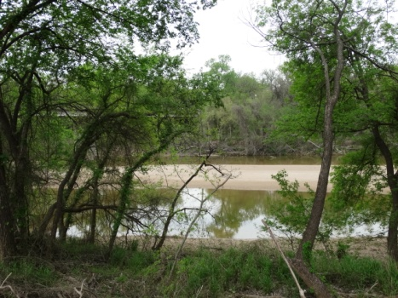

­

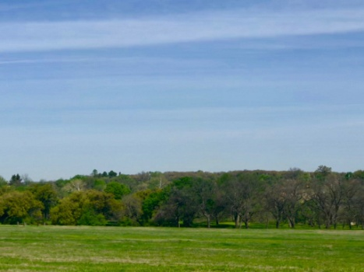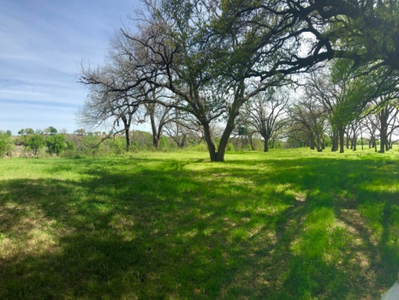

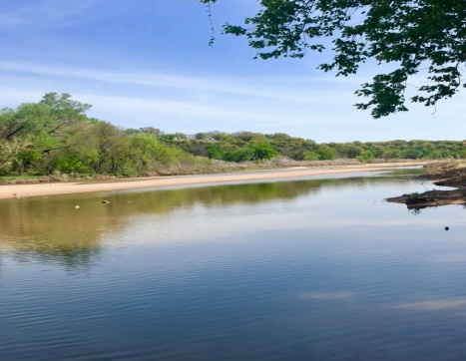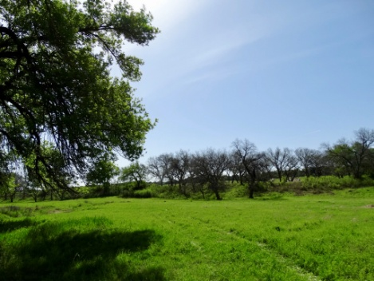

**CALL FOR A COMPLETE INFORMATION PACKET**

Legal Description: 77.310 ACR TRACT 10-2 ABST A88 R

Directions:From Glen Rose go east 1 mi at intersection of 144 and 67 go east on 67 1.5 mi past golf course, turn right on to FM 200 go 4 mi to Brazos River Bridge. Property starts on the south edge of bridge on the left side. Go to 2nd gate on left to enter.



**Trinity Ranch Land gladly participates with other brokers. Buyer’s agent must accompany buyer at first showing to receive full buyer’s agent commission.

At Trinity Liveoak Real Estate, LLC/Trinity Ranch Land we strive to bring you accurate, informative and relevant information in a readable and understandable manner. We do not assume liability for typographical errors, misprints or misinformation that may have been given us, nor do we guarantee its reliability. All property is subject to change, withdrawal or prior sale. We will assist all buyers in verifying the above information to the best of our ability.**

[**karen@trinityranchland.com**](mailto:karen@trinityranchland.com) **mike@trinityranchland.com**