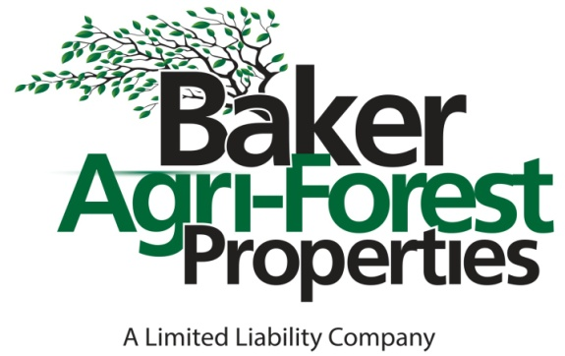

3306 Giamanco Street, Alexandria, LA 71301

P O Box 5624, Alexandria, LA 71307

Phone: 318-473-8751 Fax: 318-473-4045

Website: bakeragproperties.com

Licensed by Louisiana Real Estate Commission, USA

**Property Information Sheet**

DATE: October 25, 2022

ACREAGE: 23 Acres, more or less.

LIST PRICE: $172,500.00 ($7,500.00/Acre). Cash at closing.

LEGAL DESCRIPTION: 23 acres, more or less being all that part of the SE/4 of the SE/4 of irregular Section 12, T6N-R3W, Grant Parish, Louisiana.

LOCATION: Located adjacent to US Hwy #71 just south of the intersection of US Hwy #71 and LA Hwy #8.

DIRECTIONS: The subject lies east of US Hwy #71 approximately 1.5 miles south of the intersection of US Hwy #71 and LA Hwy #8.

Please refer to the attached maps for details. Showing is by appointment or by prior written permission. Contact Baker Agri-Forest Properties, LLC phone 318-473-8751.

GPS COORDINATES: Lat: 31.506

Long: -92.638

ACCESS: Over 1,700’ of frontage on US Hwy #71. Existing access with a culvert.

CURRENT USE: Timberland

POTENTIAL USES: Homesite/s, recreation and investment.

MINERALS: Seller will reserve 100% of all mineral rights owned.

TOPOGRAPHY: Slightly rolling

SOILS: Cadeville very fine sandy loam, 5-12% slopes 17.4 acres

Ruston fine sandy loam, 1-5% slopes 4.3 acres

Cadeville very fine sandy loam, 2-5% slopes 1.3 acres

TIMBER: The timber within the subject consists of pine timber with lesser amounts of hardwood and has been recently selectively harvested. There are no outstanding timber sale contracts and the timber conveys to the buyer.

IMPROVEMENTS: No improvements.

SPECIAL CONDITIONS: This property is owned in part by an LLC which is owned by this firm’s broker and an agent with this firm.

SITE INSPECTIONS: By appointment or by prior written permission. Please contact Baker Agri-Forest Properties, LLC

*INFORMATION DISSEMINATED ABOVE IS ASSUMED TO BE CORRECT BUT IS NOT GUARANTEED*

**NOTE: Baker Agri-Forest Properties, LLC has attempted to present the facts regarding**

**this property in a fair and accurate manner. However, it should be noted that Baker Agri-**

**Forest Properties, LLC is acting only as a real estate broker in this matter and is not licensed to perform services as a surveyor or attorney, and does not hold itself out as a**

**property inspector, accordingly it cannot be responsible for: any title or survey problems**

**concerning the above described property; any shortages in acreage or land area; the**

**accuracy of the legal description; any defects, hidden or apparent; environmental**

**problems; flooding problems; zoning, building, or wetland restrictions, easements, or any**

**other limitations preventing the full use of the above described property; or the suitability**

**of the above described property for any specific purposes or usages.**

**FOR MORE INFORMATION CALL**

**BRIAN BAIN, ROBERT TASSIN, DONALD BAKER OR MELANIE BLANCHARD @(318) 473-8751**

**VISIT OUR WEBSITE: www.bakeragproperties.com**